Assignment 2

Name: Sanjay Mahabal

Roll No.: 23101B2002

STEPS:

1. First fork the repository and then clone it.
2. Clone the Repo

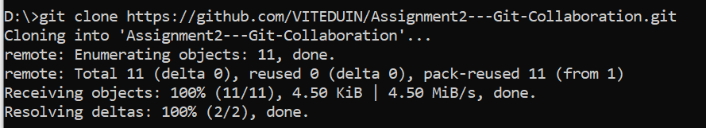

1. Go to the cloned directory

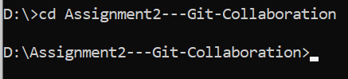

1. Check status and branch

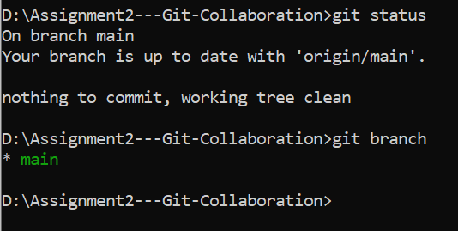

1. Create your branch  
   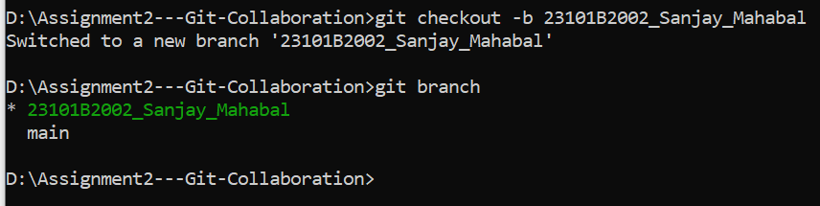
2. Add files to staging area.  
   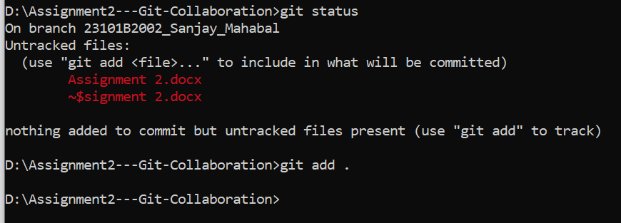
3. Files added.  
   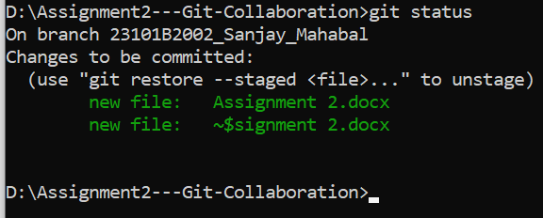
4. Commit the Changes  
   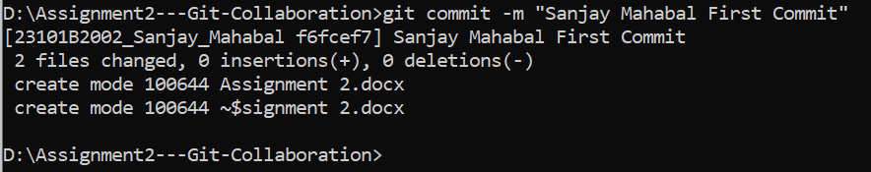
5. Push the branch to GitHub.  
   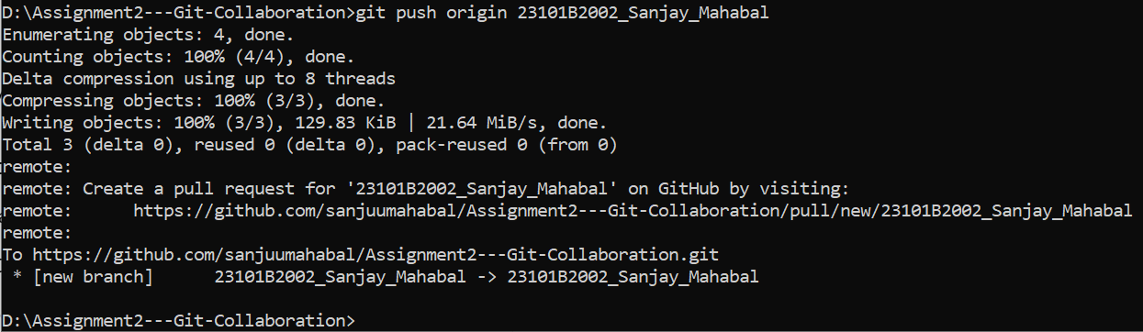
6. Create a pull request on GitHub.  
   